|  |  |  |
| --- | --- | --- |
| <https://youtu.be/8n7BtFAkTzs>  <https://youtu.be/Yq3QHtnqCZs>  <https://cracku.in/ssc-stenographer-previous-papers#mocks-list>  https://www.doubtnut.com/qna/647580074 | | |
| **3** | **4** | **5** |
| **5** | **12** | **13** |
| **8** | **15** | **17** |
| **7** | **24** | **25** |
| **20** | **21** | **29** |

**Six houses, A, B, C, D, E and F, are situated in a colony. P is 60 m south of E. F is 40 m south Of B. A is 30 m north of E. F is 50 m east Of A. C is 50 m west Of B. Find the location of C with reference to A.**

**Gaurav exits from the backdoor of his north-facing house and walks 25 m**

**straight, then he takes a left turn and walks 36 m, then he turns left and**

**walks 47 m. He turns left again and walks 36 m. How far and in which**

**direction is he from his house now?**

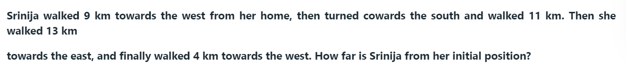

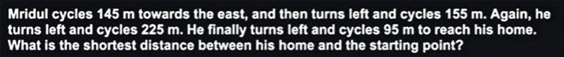

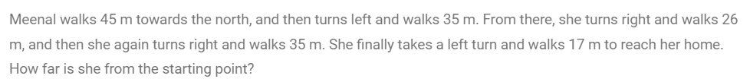

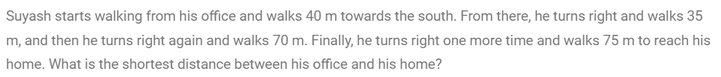



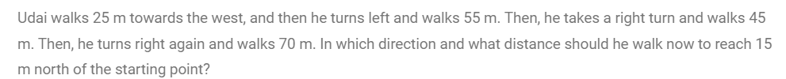

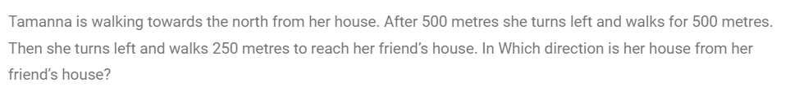

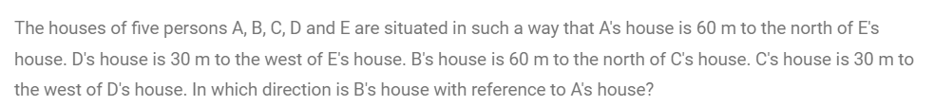



East

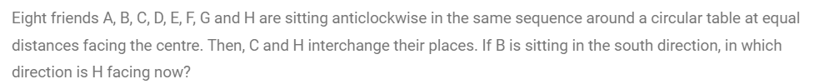

N-W

S-E

S

S-W



N

N-E

N-W

15KM



5KM

24

1KM



15KM

15KM



